**WEEK 7 LAB ASSESSMENT**

**‘Affan Najiy bin Rusdi (220100453) (TECH2-B)**

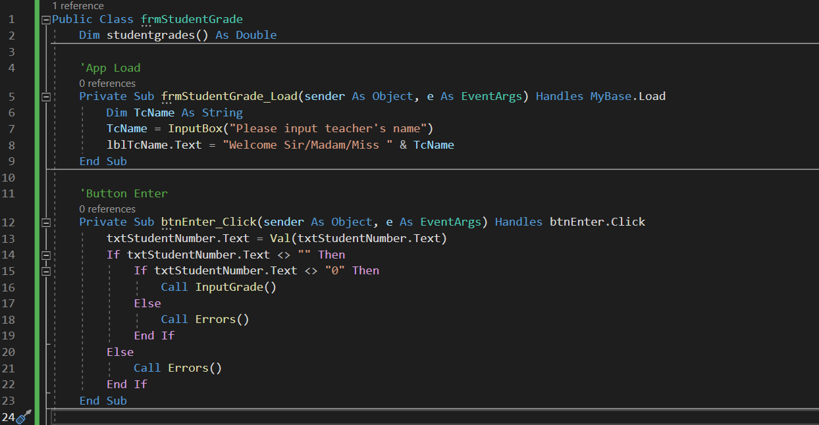**Code**

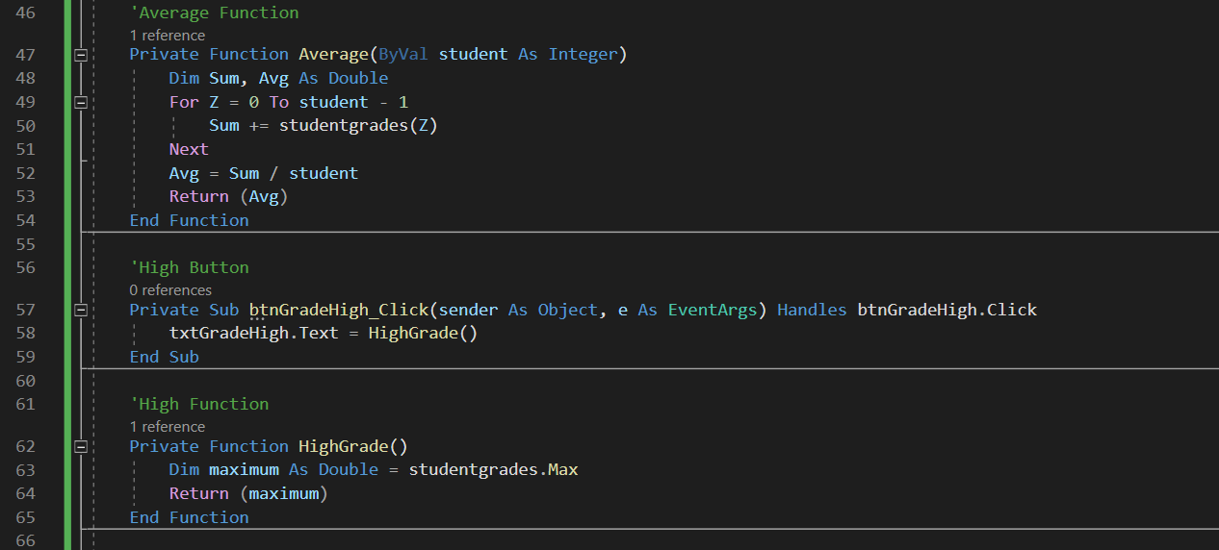

**Process:**

1. Load

1. Front End

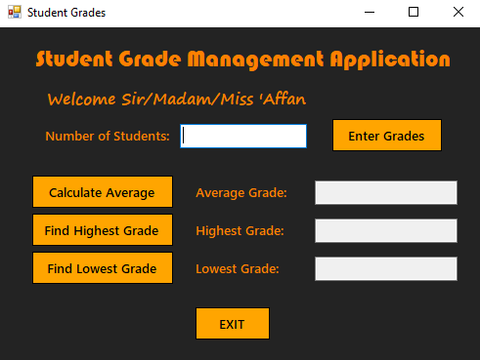

1. Input Box

1. Sample 1

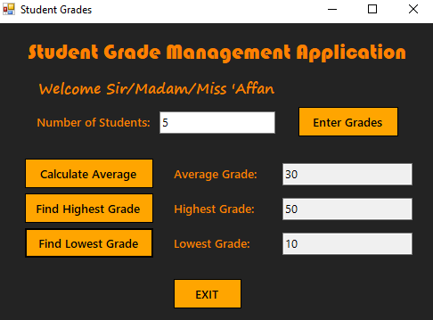

1. Sample 2

1. Sample 3

1. Error Invalid Input

1. Exit Confirmation

